REMEMBER: Write the state names in (1) English OR (2) 2-letter abbreviations AND katakana
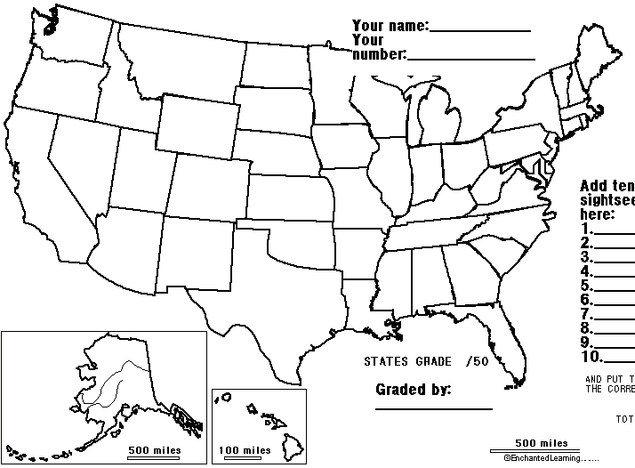

ADD Ten spots Which state?
1. ______________________ ( )
2. ______________________ ( )
3. ______________________ ( )
4. ______________________ ( )
5. ______________________ ( )
6. ______________________ ( )
7. ______________________ ( )
8. ______________________ ( )
9. ______________________ ( )
10. ______________________ ( )

______/10 _______/60

For graders: GRADE the 50 states only. Spelling mistakes: 1/2 off. Write your name under the grade! Do NOT grade cities part

