Comparison of English vs. (your language) phonology
(your name your number)
(today’s date)

- Introduction

(WRITE an introductory paragraph: what is your paper about? What is the structure?)

2. Phonetic Inventory

(WRITE an introductory paragraph: what will you write about in section 2?)

2.1 Consonants

(WRITE an introductory paragraph)

(add your language’s consonant chart here)

Chart 1. (Your language) Consonant Chart (from: Maddieson, I. 1984. Patterns of Sounds. Cambridge: Cambridge University Press.) Available at http://classweb.gmu.edu/accent/
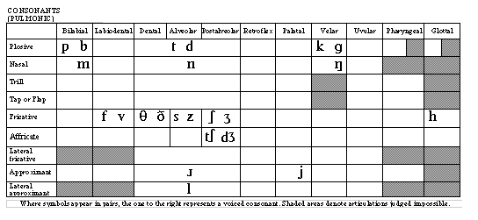
Chart 2. American English Consonant Chart (from: Maddieson, I. 1984. Patterns of Sounds. Cambridge: Cambridge University Press.) Available at http://classweb.gmu.edu/accent/
(WRITE discussion paragraphs contrasting consonants)
(write a closing paragraph for consonants)

2.2. Vowels

(WRITE an introductory paragraph)

(add your language’s vowel chart here)

Chart 3. (Your language) Vowel Chart (from: Maddieson, I. 1984. Patterns of Sounds. Cambridge: Cambridge University Press.) Available at http://classweb.gmu.edu/accent/

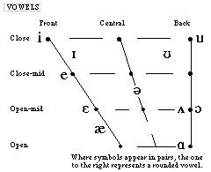
Chart 4. American English Consonant Chart (from: Maddieson, I. 1984. Patterns of Sounds. Cambridge: Cambridge University Press.) Available at http://classweb.gmu.edu/accent/

(WRITE discussion paragraphs contrasting vowel quality, length, diphthongs etc.)

(write a closing paragraph for vowels)

3. Suprasegmental phonology
(WRITE an introductory paragraph: what is included in suprasegmental phonology?)

3.1. Syllable structure

(WRITE discussion paragraphs)

3.2. Word and sentence stress

(WRITE discussion paragraphs)

3.3. Intonation

(WRITE discussion paragraphs)

4. Relation between sound and spelling or orthography

(WRITE an introductory paragraph)
(WRITE discussion paragraphs)

5. Conclusions

(Write concluding remarks. Summarize your research, what you learned, etc.)

6. Bibliography

Maddieson, I. 1984. Patterns of Sounds. Cambridge: Cambridge University Press.) Available at http://classweb.gmu.edu/accent/

(add other sources as necessary)

